Post Bone Grafting Instructions
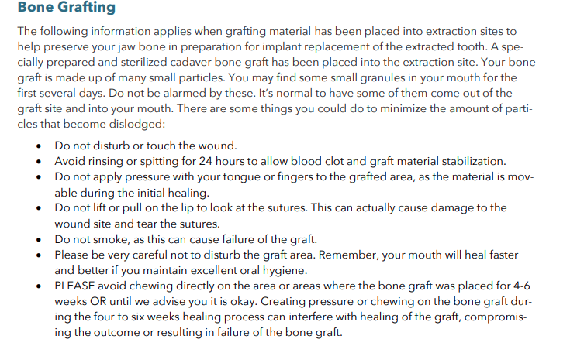

***If a membrane was placed:
FIRST 3 DAYS POSTOPERATIVE:
The patient should refrain from rinsing, sucking, and spitting for 3 days following surgery. Overly aggressive rinsing with any solution during this early phase of healing can dislodge BioXclude (the membrane).

POST-OPERATIVE CARE:
On days 4-7 gentle rinsing with ONLY TAP WATER is allowed. The patient should not use any oral rinse the first week after treatment. This includes antiseptics, chlorhexidine, chlorhexidine without alcohol, essential oils and methyl salicylate (Listerine), hydrogen peroxide, and anti-inflammatories, natural antioxidants (AO Prorinse) and botanicals, and saltwater rinses. Oral rinses are used to kill bacteria and to varying degrees adversely impact the health of gingival cells potentially slowing wound closure. At one week the patient may begin using an oral rinse for plaque control.

